Wish you could reach out to anyone?



EXPAND YOUR BUSINESS
with Translation in over 100 languages!

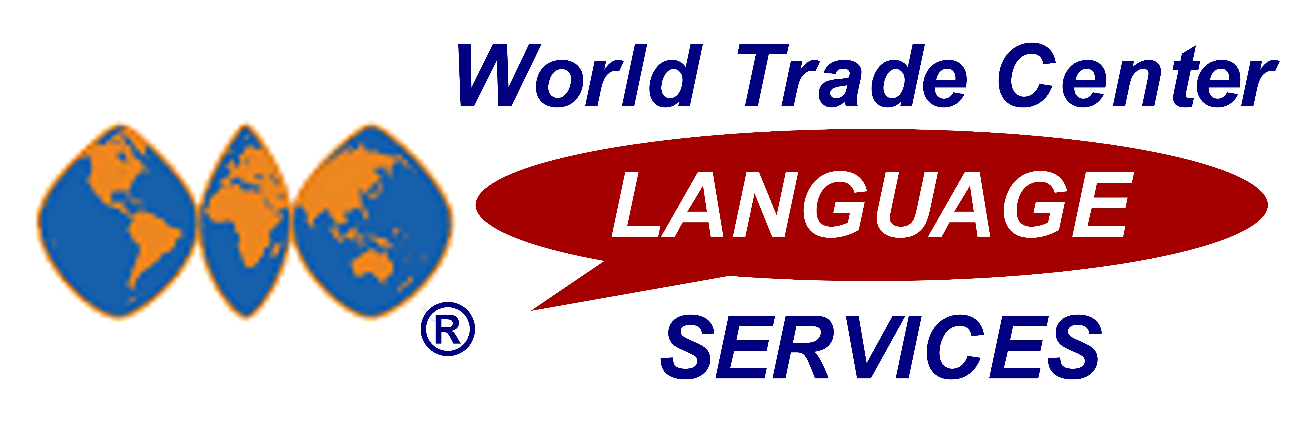
Special for friends of WTC St. Louis –
SAVE 10-42% … inquire TODAY

Document Translation:
Highly accurate, ON TIME, in 100+ languages

LIVE Phone Interpretation:

Your “on-demand” interpreter in 100+ languages

EASY to use – integrates easily with WTC Conference Calls or on a one-to-one conversation
- IMMEDIATE interpretation – over 100 languages available, including less-frequent language pairs
- LOWEST per-minute rates available – economically converse in 100+ languages ON DEMAND in seconds
- SKILLED LIVE INTERPRETERS – certified and knowledgeable in language and cultural nuances
- IDEAL FOR GLOBAL BUSINESS – negotiate, make presentations, discuss initiatives in your global partners’ languages with ACCURATE understanding

- SPECIAL WTC DISCOUNT – SAVE 10% on the same translation services used by the Fortune 500
- FASTEST TURNAROUND TIME – (25-30% faster than the rest of the translation industry)
- OVER 100 LANGUAGES AVAILABLE – translate from & to any language; 4000+ skilled translators
- INDUSTRY SPECIALISTS ENSURE CURRENT TERMINOLOGY – full-service translation services

ISO 9001:2000 CERTIFIED – 3-step translation process (translation, proofreading, editing) ensures finely-polished translations

◻ I’m interested… My Name: __________________________________ WTC affiliation: St. Louis__
Company Name: __________________________ Phone: _______________ Email: _____________________

BREAK the “language barrier” TODAY. Return this to: Fax (800) WTC-2044
Call (800) WTC-9DOC for info on Document Translation in over 100 languages.
Call (800) WTC-LANG for info on LIVE Phone Interpretation in over 100 languages.

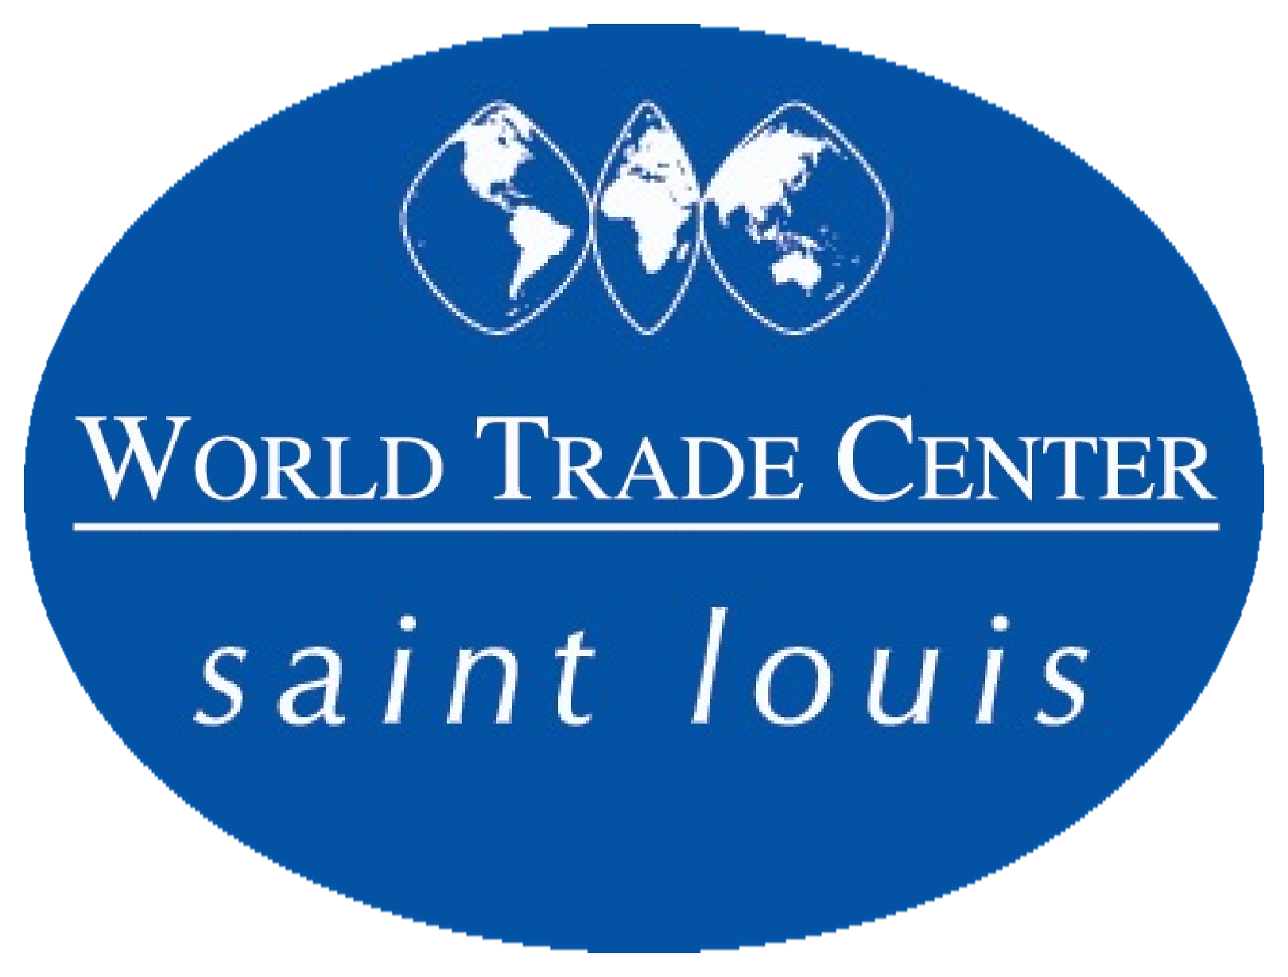

Document Translation and LIVE Phone Interpretation

available in over 100 languages

We provide FAST, ACCURATE Document Translation to & from any of these languages. Also, LIVE Phone Interpretation is available ON-DEMAND from English into these languages and between many of these language pairs:

 | Afghani |  | Croatian |  | Ga |  | Kurdish |  | Ojibway |  | Somali
 | Afrikaans |  | Czech |  | German |  | Lao |  | Ojicree |  | Spanish
 | Akan |  | Danish |  | Greek |  | Latin |  | Oromo |  | Swahili
 | Albanian |  | Dari |  | Gujarati |  | Lingala |  | Polish |  | Swedish
 | Amharic |  | Dene |  | Hakka |  | Lithuanian |  | Portuguese |  | Tagalog
 | Arabic |  | Dinka |  | Havari |  | Low German |  | Punjabi |  | Taiwanese
 | Armenian |  | Dutch |  | Hebrew |  | Lugbara |  | Pushto |  | Tamil
 | Azeri |  | Eritrean |  | Hindi |  | Macedonian |  | Romanian |  | Thai
 | Belorussian |  | Estonian |  | Hungarian |  | Madi |  | Russian |  | Tigrinya
 | Bengali |  | Fante |  | Ilocano |  | Malay |  | Sanskrit |  | Turkish
 | Bosnian |  | Farsi |  | Indonesian |  | Malayalam |  | Saulteaux |  | Turkmen
 | Bulgarian |  | Finnish |  | Inuktitut |  | Mandarin |  | Serbian |  | Twi/Asante
 | Burmese |  | Flemish |  | Italian |  | Marathi |  | Serbo-Croatian |  | Ukrainian
 | Cambodian |  | Formosan |  | Japanese |  | Micif |  | Shanghainese |  | Urdu
 | Cantonese |  | French (Canadian) |  | Kakwa |  | Min Nan |  | Shona |  | Uyghur
 | Cebuano |  | French (Continental) |  | Khmer |  | Ndebele |  | Sicilian |  | Veneto
 | Chao Chow |  | Frisian |  | Kinyarwanda |  | Nepali |  | Sindhi |  | Vietnamese
 | Cree |  | Fuchownese |  | Kirundi |  | Norwegian |  | Sinhala |  | Yiddish
 | Creole |  | Fukianese |  | Kiswahili |  | Nuer |  | Slovakian
Creole-Haitian |  | Fur |  | Korean |  | Nzema |  | Slovenian

The importance of “breaking the language barrier”
for your global business success
Your World Trade Center is proud to offer you the power to communicate in virtually any language through our WTC Language Services program.
Enhanced communication through accurately-translated documents and through skilled, LIVE interpreters is vital to making the connections that are the basis of your success in global business.
People live and think in their native language. If you want to ensure your message is understood, maintain goodwill, loyalty, and communicate successfully with your global partners, you MUST be prepared to speak and provide documents in the business language of their choice
Millions of dollars in business are being lost every day because language barriers and mistakes in communication get in the way of potential customers. Even if you don’t feel you’re losing customers or business opportunities, imagine the additional revenue your company would generate if you could effectively expand into markets in countries and languages you are not currently serving.
WTC Language Services Document Translation and Phone Interpretation can expand your global business opportunities with access to high-quality, personal language services.

