Wish you could reach out to anyone?



EXPAND YOUR BUSINESS
with Translation in over 100 languages!

Document Translation:
Highly accurate, ON TIME, in 100+ languages

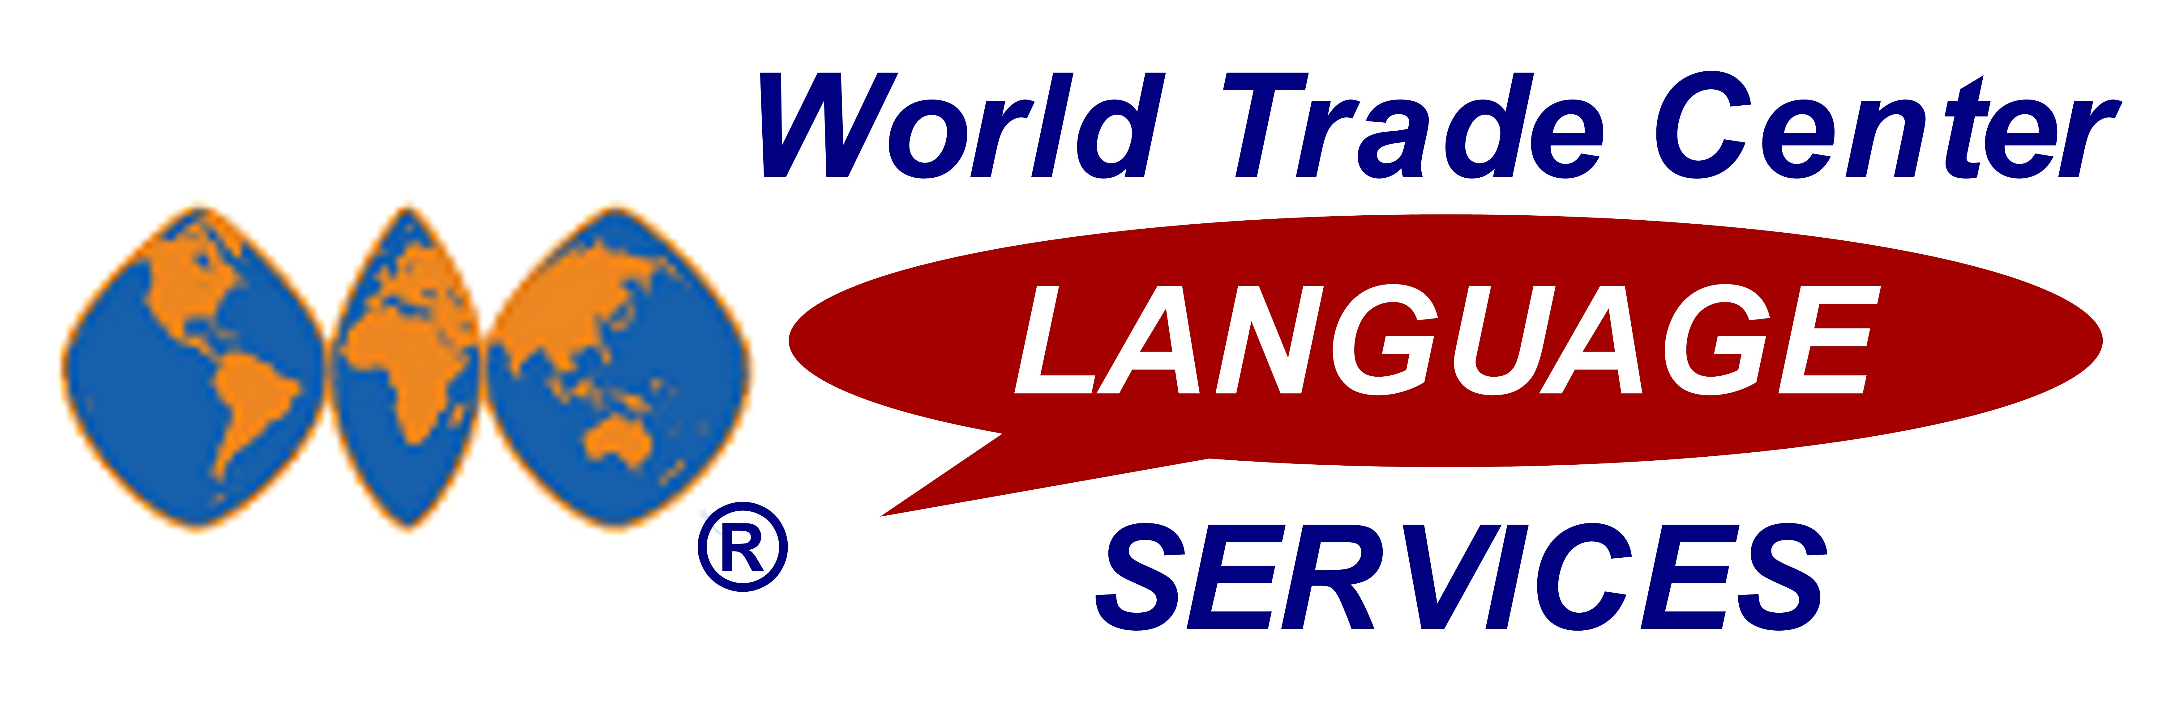
- SPECIAL WTC DISCOUNT – SAVE 10% on the same translation services used by the Fortune 500
- FASTEST TURNAROUND TIME – (25-30% faster than rest of the translation industry)
- OVER 100 LANGUAGES AVAILABLE – translate from & to any language; 4000+ skilled translators
- INDUSTRY SPECIALISTS ENSURE CURRENT TERMINOLOGY – full-service translation services

ISO 9001:2000 CERTIFIED – 3-step translation process (translation, proofreading, editing) ensures finely-polished translations

◻ I’m interested…I want to break the “language barrier” today.
My Name: ___________________________ Company: _________________________WTC: North Carolina
Phone: ______________________________________ Email: ________________________________________

For more info, please complete & fax this page to: (800) WTC-2044. Visit www.WTCTranslation.com or call (800) WTC-9DOC for more info on FAST & ACCURATE document translation in over 100 languages.

Special for friends of WTC North Carolina –
SAVE 10% … inquire TODAY

* Submit your first Document Translation Request Form and receive one week FREE trial of our WTC Conference Calls UNLIMITED conferencing service for UNLIMITED conference calls ANY where, ANY time.

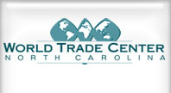
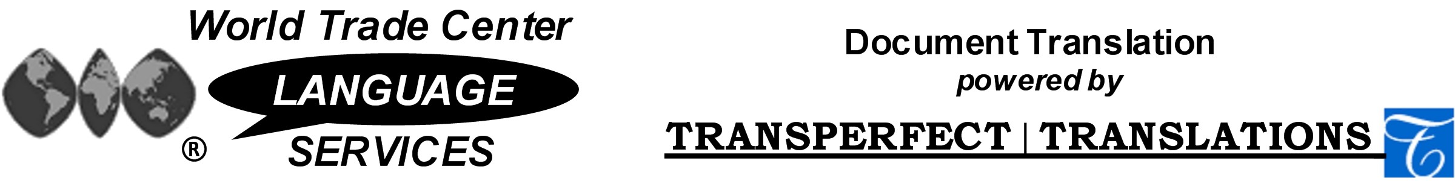

Office of WTC Translations ▪ Ph: (800) WTC - 9DOC ▪ Fax: (800) WTC - 2044 ▪ WTC@TransPerfect.com

Document Translation Language Capabilities
Translate FROM and TO these languages:

Afrikaans | Akan | Albanian | Amharic | Arabic | Armenian
Azerbaijani | Belorussian | Bengali | Bulgarian | Burmese | Cambodia
Catalan | Chinese | Croatian | Czech | Danish | Dutch
Dzongkha | English | Estonian | Farsi | Finnish | Flemish
French | Gaelic | Georgian | German | Greek | Gujarat
Haitian Creole | Hebrew | Hindi | Hmong | Hungarian | Icelandic
Indonesian | Italian | Japanese | Javanese | Jonkha | Kannada
Kazakh | Khalkha | Khmer | Korean | Kurdish | Lao
Latin | Latvian | Lingala | Lithuanian | Macedonian | Malagasy
Malay | Maltese | Marathi | Marshallese | Mongolian | Nepali
Norwegian | Nyanja | Pashto | Polish | Portuguese | Punjab
Quechua | Romanian | Romansch | Rundi | Russian | Samoan
Serbian | Sinhalese | Slovak | Slovene | Somali | Sotho
Spanish | Swahili | Tagalog | Tamil | Tegalu | Thai
Tigrinya | Trukese | Tswana | Turkish | Turkmen | Ukrainian
Uzbek | Vietnamese | Welsh | Yao | Yiddish | Zulu

World Trade Center Language Services Document Translation
WTC Language Services is proud to offer to World Trade Centers and their affiliated companies worldwide a highly-accurate, fast turnaround (25-30% faster than the rest of the industry) Document Translation service. This service, powered by TransPerfect Translations, Inc., one of the world’s leading Document Translation providers, is being offered at a special 10% discount.
This 10% WTC discount off TransPerfect’s world-class translation services represents an offer unique in the translation marketplace. TransPerfect has never before given such a generous group discount.

Pricing for WTC Document Translation Services:

Document Translation services: Contact the Office of WTC Translations for pricing of specific projects. Priced according to language pairs (source language FROM and target language TO) and services provided. A written estimate will be offered when the WTC Document Translation Request Form is completed.
The WTC Document Translation Request Form ensures you receive the special 10% World Trade Center discount, offered exclusively for WTC Affiliated Companies and unavailable elsewhere.

Office of WTC Translations ▪ Ph: (800) WTC - 9DOC ▪ Fax: (800) WTC - 2044 ▪ WTC@TransPerfect.com

Even if you already use another translation service, you should give WTC Document Translation powered by TransPerfect a try… here are 10 reasons why:
- Special 10% WTC discount – World-Class quality at discount prices unavailable elsewhere
- Quickest turnaround times (25-30% faster than the rest of the industry)
- One of the top 3 translation services vendors in the US, and one of the top 5 globally, with superior 24/7 customer service and geographic breadth – 21 offices worldwide to serve you.
- ISO 9001: 2000 Certification (the only translation company of the global top 5 to achieve this status). The International Standards Organization (ISO) is a network of the national standards institutes of 147 countries. The ISO sets rigorous standards for government and industry.
- A network of 4000+ certified linguists who are ALSO industry specialists AND native speakers in their target languages – with advanced degrees and industry-specific hands-on experience, ensuring the highest possible level of accuracy and knowledge of current terminology. TransPerfect linguists are certified (ATA, NAJIT, IOL, AITC, and AIIC) with 5 years expertise translating in their industry specialization. Skill levels are rigorously tested & re-tested.
- Language services in 100+ languages – translation capability from AND to ANY language at competitive rates, charged at a reasonable per-word rate. Written estimates provided in advance.
- Your project will be given industry-expert personal attention – a project manager & 3-person team (a translator, an editor, and a proofreader) to ensure flawless translation and quality control. Translation project managers, on-call 24/7, keep your translation project on-time and on-budget
- Industry Specialists – in all major fields:
  - legal
  - financial & accounting
  - pharmaceutical / health care / medical devices
  - manufacturing / industrial equipment / engineering
  - mining & energy
  - automotive & transportation
  - retail & consumer products
  - marketing & advertising
  - computer hardware / software / telecommunications / high-technology
  - media & entertainment
- Translation Memory tools – reduce your costs and improve consistency by using phrases already translated in an existing document or in your current translation project
- FULL-SERVICE Language Services:
- Document Translation – finely-polished translations – accurate and ON TIME
- On-site Interpretation – for presentations and business meetings
- Multilingual Typesetting, Graphics, and Desktop Publishing Services
- Web Site Globalization / Software Localization – with expertise in Japanese, Chinese, Korean, Hebrew, Cyrillic, and Arabic alphabets
- Multimedia Presentations/Subtitling/Voice-overs – professional audio studios and on-air talent

Office of WTC Translations ▪ Ph: (800) WTC - 9DOC ▪ Fax: (800) WTC - 2044 ▪ WTC@TransPerfect.com

Six Ways You Can Profitably Use Document Translation
Here are some of the profitable ways that you can benefit from WTC Document Translation services:

- WTC Members, Tenants, and Affiliated Companies – you can use this high-quality, economical document translation service to expand your business and promote your services to potential clients in countries around the world. Whether you are a law firm, corporate legal department, financial planner, banker, accountant, or manufacturers' representative, we can translate your company policies, employee handbooks, and other internal corporate documents for non-English-speaking employees.
- Global trading companies, exporters, and importers – you can expand your business into new global markets with properly translated NAFTA trade information and import/export documents such as tax documents, financial and banking documents, contracts, bills of lading, shipping documents, rules and regulations, country of origin and product content documents.
- Multinational companies – you need document translation every time you enter a new market – to translate legal documents, marketing materials, Codes of Conduct and Ethics Policies, packaging / labelling / product instructions, advertising / promo materials, multi-lingual typesetting, multi-lingual multi-media presentations, multi-cultural marketing, in-language copy writing, subtitling of voice-overs for commercials, IVRs, TV / radio spots, news articles, press releases, and news clippings.
- Law Firms and Corporate Legal Departments – translate contracts, representative agreements, reseller agreements, VAR/distributor agreements, service agreements, customer agreements, and other legal documents such as transcriptions, depositions, financial prospectuses, financial statements and research reports.
- Manufacturers – you can streamline your off-shore operations and customize turn-key plant and facilities operations with country-specific translation of operational manufacturing procedures, employee handbooks and notices, equipment and maintenance instructions, blueprints, corporate policies, export/import documents, and feedback to headquarters of local laws, notices, and market intelligence.
- Technology, software & web site development teams – you can dramatically expand your profitable penetration into new markets by translating software applications in their entirety, thereby permitting software localization for new markets around the world. In addition, our country-specific, multi-language web site translations create web sites that are truly global – increasing market share and profitability. You can receive quick translation of technical manuals and development applications, both into and out of the local language, thereby enhancing their speed-to-market, hence market share and profitability.

Use our services with confidence. Your translation projects will be handled with superior customer service by our translation project managers, available 24/7. The security and confidentiality of your corporate documents and information is protected. Our network of 4000+ certified linguists and our ISO 9001:2000 Certified process ensure flawless translations. As a WTC Affiliated Company you will enjoy access to the same highly accurate document translation used by Fortune Global 500 companies, at a special 10% discount. So, request a free quote on your translation project and expand your market worldwide.

