Wish you could reach out to ANYone?
◻ I’m interested…I want to break the “language barrier” today.
My Name: _____________________________ Company: __________________________WTC: Philadelphia
Phone: ______________________________________ Email: ________________________________________

For more info, please complete & fax this page to: (800) WTC-2044. Visit www.WTCInterpretation.com or call (800) WTC-LANG for more info on LIVE Phone Interpretation in over 100 languages.



EXPAND YOUR BUSINESS
with Interpretation in over 100 languages!

LIVE Phone Interpretation:

Your “on-demand” interpreters in 100+ languages

*Phone Interpretation includes 1 week FREE trial of WTC Conference Calls 10-user license for UNLIMITED conferencing ANY where, ANY time.

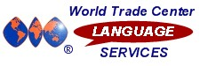

EASY to use – integrates easily with WTC Conference Calls or on a 1-to-1 conversation
- IMMEDIATE interpretation – over 100 languages available, including less-frequent language pairs
- LOWEST per-minute rates available – why hire an expensive interpreter for only a 20-min. interpretation?
- SKILLED LIVE INTERPRETERS – certified and knowledgeable in language and cultural nuances
- IDEAL FOR GLOBAL BUSINESS – negotiate, make presentations, discuss initiatives, CLOSE SALES in your global partners’ languages with ACCURATE understanding

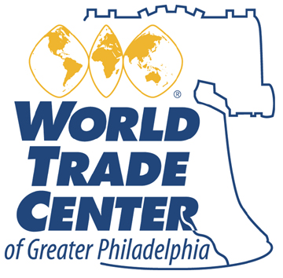

Special for friends of WTC of Greater Philadelphia –
SAVE up to 40%...inquire TODAY

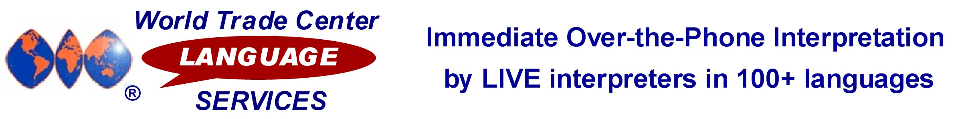
The importance of “breaking the language barrier”
for your global business success
Your World Trade Center is proud to offer you the power to communicate in virtually any language through our WTC Language Services program.
Enhanced communication through skilled, LIVE interpreters is vital to making the connections that are the basis of your success in global business.
People live and think in their native language. If you want to ensure your message is understood, maintain goodwill, loyalty, and communicate successfully with your global partners, you MUST be prepared to speak in the business language of their choice
Millions of dollars in business are being lost every day because language barriers and mistakes in communication get in the way of potential customers. Even if you don’t feel you’re losing customers or business opportunities, imagine the additional revenue your company would generate if you could effectively expand into markets in countries and languages you are not currently serving.
WTC Language Services Phone Interpretation can expand your global business opportunities with access to high-quality, personal language services.

LIVE Phone Interpretation

– available in over 100 languages

LIVE Phone Interpretation is available ON DEMAND from English

into these languages and between pairs of many of these languages:

 | Afghani | Croatian | Ga | Kurdish |  | Ojibway | Somali
 | Afrikaans | Czech | German | Lao |  | Ojicree | Spanish
 | Akan | Danish | Greek | Latin |  | Oromo | Swahili
 | Albanian | Dari | Gujarati | Lingala |  | Polish | Swedish
 | Amharic | Dene | Hakka | Lithuanian |  | Portuguese | Tagalog
 | Arabic | Dinka | Havari | Low German |  | Punjabi | Taiwanese
 | Armenian | Dutch | Hebrew | Lugbara |  | Pushto | Tamil
 | Azeri | Eritrean | Hindi | Macedonian |  | Romanian | Thai
 | Belorussian | Estonian | Hungarian | Madi |  | Russian | Tigrinya
 | Bengali | Fante | Ilocano | Malay |  | Sanskrit | Turkish
 | Bosnian | Farsi | Indonesian | Malayalam |  | Saulteaux | Turkmen
 | Bulgarian | Finnish | Inuktitut | Mandarin |  | Serbian | Twi/Asante
 | Burmese | Flemish | Italian | Marathi |  | Serbo-Croatian | Ukrainian
 | Cambodian | Formosan | Japanese | Micif |  | Shanghainese | Urdu
 | Cantonese | French-Canadian | Kakwa | Min Nan |  | Shona | Uyghur
 | Cebuano | French-Continental | Khmer | Ndebele |  | Sicilian | Veneto
 | Chao Chow | Frisian | Kinyarwanda | Nepali |  | Sindhi | Vietnamese
 | Cree | Fuchownese | Kirundi | Norwegian |  | Sinhala | Yiddish
 | Creole | Fukianese | Kiswahili | Nuer |  | Slovakian
Creole-Haitian |  | Fur | Korean |  | Nzema | Slovenian

