Wish you could reach out to anyone?



EXPAND YOUR BUSINESS
with Translation in over 100 languages!

WTC Document Translation
Highly accurate, ON TIME, in 100+ languages

WTC Phone Interpretation

Your “on-demand” interpreter in 100+ languages

EASY to use – integrates easily with WTC Conference Calls or on a one-to-one conversation
- IMMEDIATE interpretation – over 100 languages available, including less-frequent language pairs
- LOWEST per-minute rates available – save 40% and converse in 100+ languages ON DEMAND in seconds
- SKILLED LIVE INTERPRETERS – certified and knowledgeable in language and cultural nuances
- IDEAL FOR GLOBAL BUSINESS – negotiate, make presentations, discuss initiatives in your global partners’ languages with ACCURATE understanding

- SPECIAL WTC DISCOUNT – SAVE 10% on the same translation services used by the Fortune 500
- FASTEST TURNAROUND TIME – (25-30% faster than rest of the translation industry)
- OVER 100 LANGUAGES AVAILABLE – translate from & to any language; 4000+ skilled translators
- INDUSTRY SPECIALISTS ENSURE CURRENT TERMINOLOGY – full-service translation services

ISO 9001:2000 CERTIFIED – 3-step translation process (translation, proofreading, editing) ensures finely-polished translations

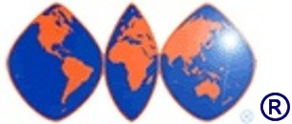
* Any Phone Interpretation or Document Translation service includes FREE trial of WTC Conference Calls service for UNLIMITED conference calls ANY where, ANY time. Phone Interpretation available for many languages within 60 seconds. Call to learn how fast your language needs can be met. Download Phone Interpretation activation form for pricing details, and Document Translation Request Form for a bid on a translation project.
◻ I’m interested…I want to break the “language barrier”
My Name: __________________________ Company: _________________________
Phone: ________________________ Email: _________________________________

For more info, please fill out & fax this page to: (800) WTC-2044. Or, call (800) WTC-LANG [982-5264], email info@WTCLanguage.com or visit www.WTCInterpretation.com and www.WTCTranslation.com

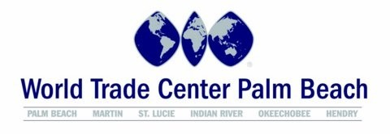

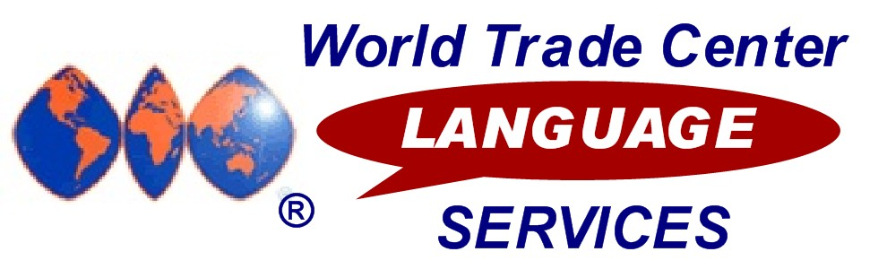
The importance of “breaking the language barrier”
for your global business success
Your World Trade Center is proud to offer you the power to communicate in virtually any language through our WTC Language Services program.
Enhanced communication through ACCURATE document translation and skilled, LIVE interpreters is vital to making the connections that are the basis of your success in global business.
People live and think in their native language. If you want to ensure your message is understood, maintain goodwill, loyalty, and communicate successfully with your global partners, you MUST be prepared to communicate in the business language of their choice – whether using the written or spoken word.
Millions of dollars in business are being lost every day because language barriers and mistakes in communication get in the way of potential customers. Even if you don’t feel you’re losing customers or business opportunities, imagine the additional revenue your company would generate if you could effectively expand into markets in countries and languages you are not currently serving.
WTC Language Services Document Translation and Phone Interpretation can expand your global business opportunities with access to high-quality, personal language services.

Document Translation and LIVE Phone Interpretation – available from English

into these languages and between pairs of many of these 100+ languages:

 | Afghani | Croatian | Ga | Kurdish |  | Ojibway | Somali
 | Afrikaans | Czech | German | Lao |  | Ojicree | Spanish
 | Akan | Danish | Greek | Latin |  | Oromo | Swahili
 | Albanian | Dari | Gujarati | Lingala |  | Polish | Swedish
 | Amharic | Dene | Hakka | Lithuanian |  | Portuguese | Tagalog
 | Arabic | Dinka | Havari | Low German |  | Punjabi | Taiwanese
 | Armenian | Dutch | Hebrew | Lugbara |  | Pushto | Tamil
 | Azeri | Eritrean | Hindi | Macedonian |  | Romanian | Thai
 | Belorussian | Estonian | Hungarian | Madi |  | Russian | Tigrinya
 | Bengali | Fante | Ilocano | Malay |  | Sanskrit | Turkish
 | Bosnian | Farsi | Indonesian | Malayalam |  | Saulteaux | Turkmen
 | Bulgarian | Finnish | Inuktitut | Mandarin |  | Serbian | Twi/Asante
 | Burmese | Flemish | Italian | Marathi |  | Serbo-Croatian | Ukrainian
 | Cambodian | Formosan | Japanese | Micif |  | Shanghainese | Urdu
 | Cantonese | French-Canadian | Kakwa | Min Nan |  | Shona | Uyghur
 | Cebuano | French-Continental | Khmer | Ndebele |  | Sicilian | Veneto
 | Chao Chow | Frisian | Kinyarwanda | Nepali |  | Sindhi | Vietnamese
 | Cree | Fuchownese | Kirundi | Norwegian |  | Sinhala | Yiddish
 | Creole | Fukianese | Kiswahili | Nuer |  | Slovakian
Creole-Haitian |  | Fur | Korean |  | Nzema | Slovenian

