Wish you could reach out to anyone?



EXPAND YOUR BUSINESS
with Translation in over 100 languages!

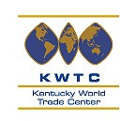
Special for friends of WTC Kentucky –
SAVE 10% … inquire TODAY

Document Translation:
Highly accurate, ON TIME, in 100+ languages

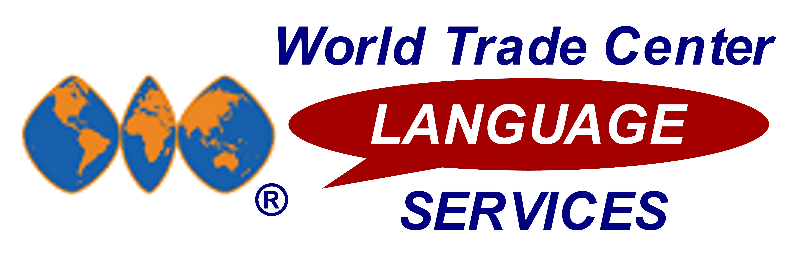
- SPECIAL WTC DISCOUNT – SAVE 10% on the same translation services used by the Fortune 500
- FASTEST TURNAROUND TIME – (25-30% faster than rest of the translation industry)
- OVER 100 LANGUAGES AVAILABLE – translate from & to any language; 4000+ skilled translators
- INDUSTRY SPECIALISTS ENSURE CURRENT TERMINOLOGY – full-service translation services

ISO 9001:2000 CERTIFIED – 3-step translation process (translation, proofreading, editing) ensures finely-polished translations

◻ I’m interested…I want to break the “language barrier” today.
My Name: _____________________________ Company: __________________________WTC: Kentucky
Phone: ______________________________________ Email: ________________________________________

For more info, please complete & fax this page to: (800) WTC-2044. Visit www.WTCTranslation.com or call (800) WTC-9DOC for more info on FAST & ACCURATE document translation in over 100 languages.

* Submit your first Document Translation Request Form and receive one week FREE trial of our WTC Conference Calls UNLIMITED conferencing service for UNLIMITED conference calls ANY where, ANY time.

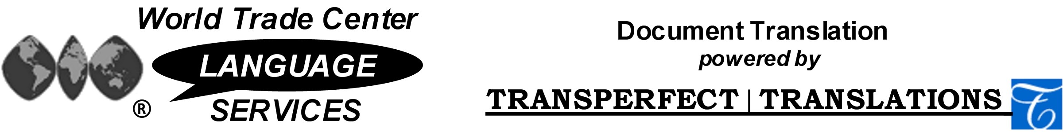

Office of WTC Translations ▪ Ph: (800) WTC - 9DOC ▪ Fax: (800) WTC - 2044 ▪ WTC@TransPerfect.com

Document Translation Language Capabilities
Translate FROM and TO these languages:

Afrikaans | Akan | Albanian | Amharic | Arabic | Armenian
Azerbaijani | Belorussian | Bengali | Bulgarian | Burmese | Cambodia
Catalan | Chinese | Croatian | Czech | Danish | Dutch
Dzongkha | English | Estonian | Farsi | Finnish | Flemish
French | Gaelic | Georgian | German | Greek | Gujarat
Haitian Creole | Hebrew | Hindi | Hmong | Hungarian | Icelandic
Indonesian | Italian | Japanese | Javanese | Jonkha | Kannada
Kazakh | Khalkha | Khmer | Korean | Kurdish | Lao
Latin | Latvian | Lingala | Lithuanian | Macedonian | Malagasy
Malay | Maltese | Marathi | Marshallese | Mongolian | Nepali
Norwegian | Nyanja | Pashto | Polish | Portuguese | Punjab
Quechua | Romanian | Romansch | Rundi | Russian | Samoan
Serbian | Sinhalese | Slovak | Slovene | Somali | Sotho
Spanish | Swahili | Tagalog | Tamil | Tegalu | Thai
Tigrinya | Trukese | Tswana | Turkish | Turkmen | Ukrainian
Uzbek | Vietnamese | Welsh | Yao | Yiddish | Zulu

World Trade Center Language Services Document Translation
WTC Language Services is proud to offer to World Trade Centers and their affiliated companies worldwide a highly-accurate, fast turnaround (25-30% faster than the rest of the industry) Document Translation service. This service, powered by TransPerfect Translations, Inc., one of the world’s leading Document Translation providers, is being offered at a special 10% discount.
This 10% WTC discount off TransPerfect’s world-class translation services represents an offer unique in the translation marketplace. TransPerfect has never before given such a generous group discount.

Pricing for WTC Document Translation Services:

Document Translation services: Contact the Office of WTC Translations for pricing of specific projects. Priced according to language pairs (source language FROM and target language TO) and services provided. A written estimate will be offered when the WTC Document Translation Request Form is completed.
The WTC Document Translation Request Form ensures you receive the special 10% World Trade Center discount, offered exclusively for WTC Affiliated Companies and unavailable elsewhere.

