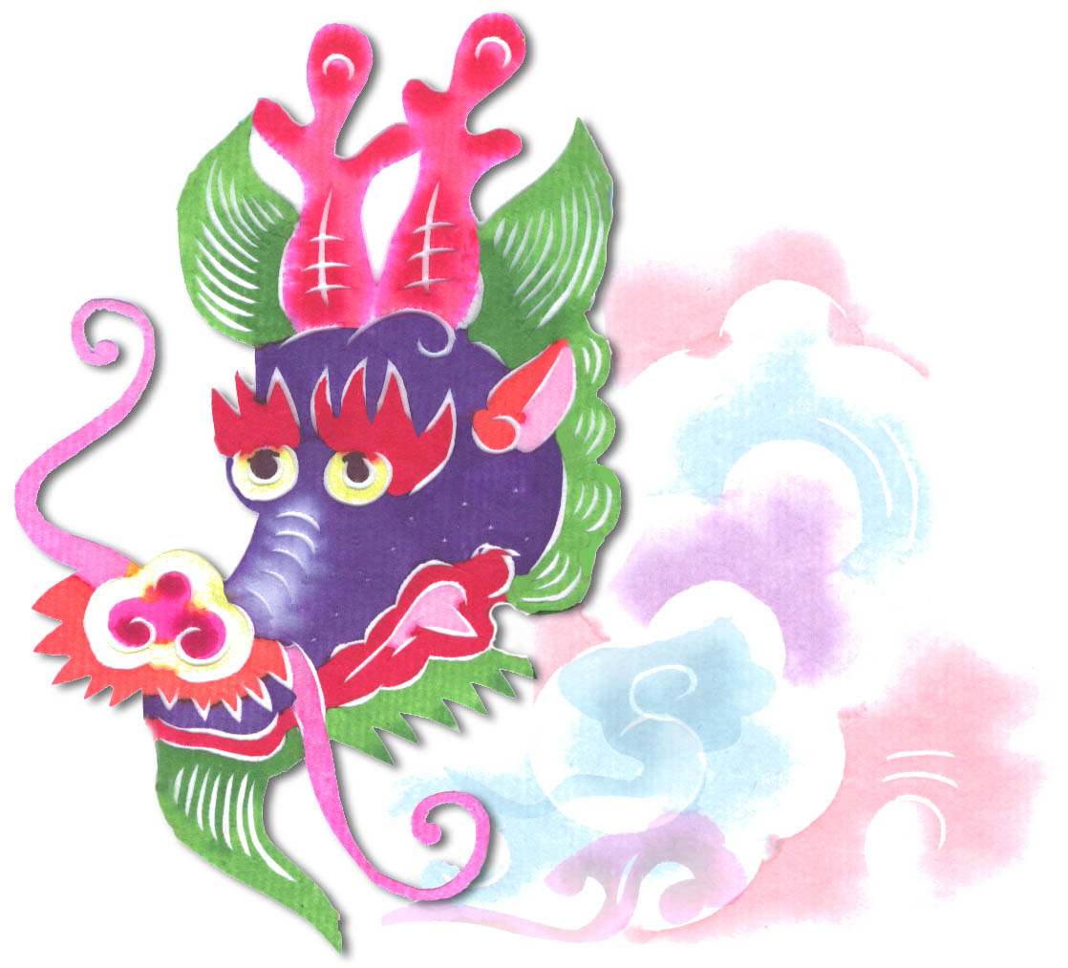  Heavenly Dragon  Designs  PCSB28 – Deer 8x10 $49 | PCS65- Vase 8x10 $49  Heavenly Dragon  Designs | PCSB04 – Birds –  Pheasants 8x10 $49  Heavenly Dragon  Designs
PCSB04 – Birds –  Longtails 8x10 $49  Heavenly Dragon  Designs | Heavenly Dragon  Designs  PCSB03 - Animals - Peacock 8x10 $49  Heavenly Dragon  Designs | Heavenly Dragon  Designs  PCS10-Flower - Peony 8x10 $49
Heavenly Dragon  Designs  L-8b2 Flower Vase 8x10 $49 | L-4b2 Flower #1 8x10 $49

