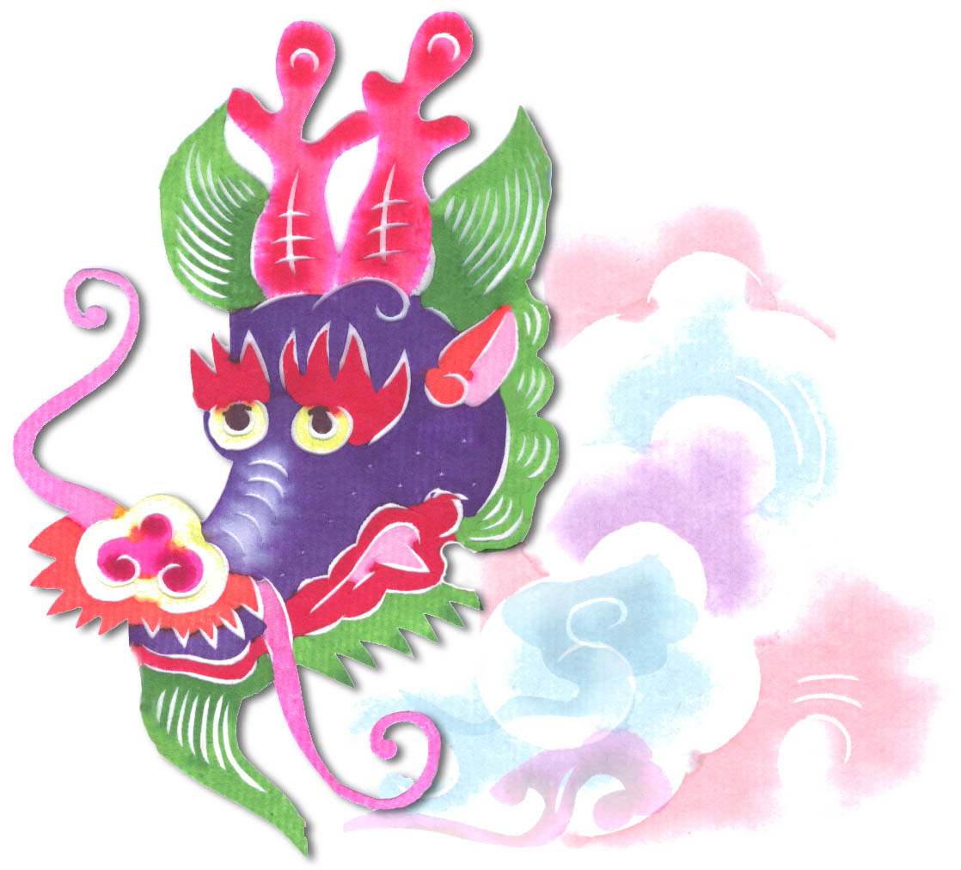  Heavenly Dragon  Designs  PCS20-Cat  8x10 $49 | PCS49-Flower in pot 1 of set of 10 8x10 $49  Heavenly Dragon  Designs | PCS49-Flower in pot 2  of set of 10 8x10 $49  Heavenly Dragon  Designs
PCS59-Birds over flowers 8x10 $49  Heavenly Dragon  Designs | Heavenly Dragon  Designs  L1 – Lady Bug  8x10 $49  Heavenly Dragon  Designs | Heavenly Dragon  Designs  L-2 Love in Chinese (“Ai”) 8x10 $49  Heavenly Dragon  Designs
Heavenly Dragon  Designs  PCS09-Fortune 8x10 $49 | PCSB37 – Insects 8x10 $49  Heavenly Dragon  Designs | Heavenly Dragon  Designs  PCS18-Butterfly over flower 8x10 $49
PCS19-Butterfly over flower 8x10 $49  Heavenly Dragon  Designs | Heavenly Dragon  Designs  PCS33-Horse  8x10 $49  Heavenly Dragon  Designs | Heavenly Dragon  Designs  PCSB46-Frog 8x10 $49  Heavenly Dragon  Designs
Heavenly Dragon  Designs  PCS55-Tiger 8x10 $49 | PCSB33 -Two Monkeys 8x10 $49  Heavenly Dragon  Designs | Heavenly Dragon  Designs  PCS03-Monkey  8x10 $49
Heavenly Dragon  Designs  PCSB32 – Double Happiness 8x10 $49 | PCSB32 – Double Happiness 8x10 $49  Heavenly Dragon  Designs | Heavenly Dragon  Designs  PCSB04 – Birds 8x10 $49
L-6 Flowers 1 of  set of 8 8x10 $49  Heavenly Dragon  Designs | Heavenly Dragon  Designs  L-6 Flowers 2 of  set of 8 8x10 $49  Heavenly Dragon  Designs | Heavenly Dragon  Designs  L-6 Flowers 3 of  set of 8 8x10 $49  Heavenly Dragon  Designs
Heavenly Dragon  Designs  L-10 Fu (”Good Luck”) 8x10 $49 | L-11 Dragonfly 8x10 $49  Heavenly Dragon  Designs | Heavenly Dragon  Designs  PCSB03 Animals – Peacock 8x10 $49
PCSB27 - Tiger 8x10 $49  Heavenly Dragon  Designs | Heavenly Dragon  Designs  PCS21-Chicken  8x10 $49 | Heavenly Dragon  Designs  PCS25-Dog 8x10 $49
PCSB26 – Peacock 8x10 $49  Heavenly Dragon  Designs | Heavenly Dragon  Designs  PCSB26 – Peacock 8x10 $49 | Heavenly Dragon  Designs  PCS52-Butterfly 8x10 $49

