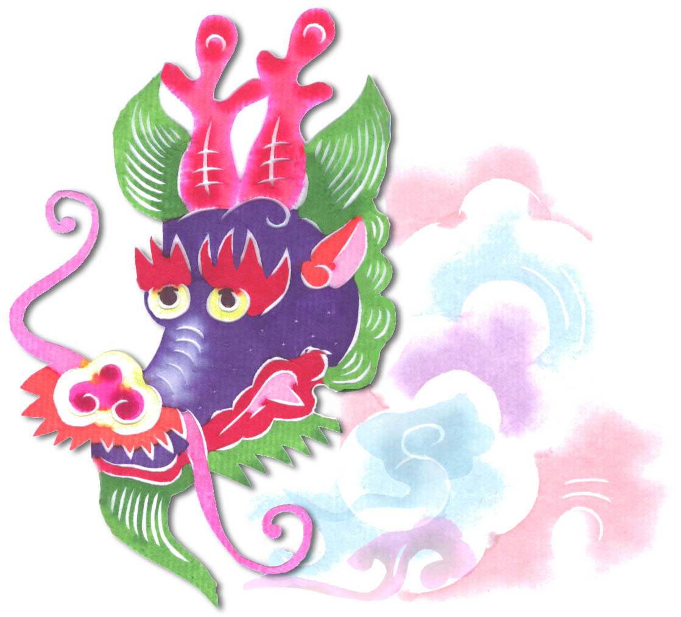  Heavenly Dragon  Designs  PCS24-Long Life Crane 1 of set of 10 8x10 $49 | PCS37-Animals 1 of 10  — Pheasant 8x10 $49  Heavenly Dragon  Designs | PCS37-Animals 1 of 10  — Phoenix 8x10 $49  Heavenly Dragon  Designs
PCSB40 – Panda 1 of set of 10 8x10 $49  Heavenly Dragon  Designs | Heavenly Dragon  Designs  PCSB40 – Panda 2 of set of 10 8x10 $49  Heavenly Dragon  Designs | Heavenly Dragon  Designs  PCSB45-Red Tiger 8x10 $49  Heavenly Dragon  Designs
Heavenly Dragon  Designs  PCSB35 – Long Life Golden Deer 8x10 $49 | PCSB42 - Lantern 1 of set of 10 8x10 $49  Heavenly Dragon  Designs | Heavenly Dragon  Designs  PCSB40 – Panda 3 of set of 10 8x10 $49
PCS31-Golden fish 8x10 $49  Heavenly Dragon  Designs | Heavenly Dragon  Designs  PCSB42 - Lantern 2 of set of 10 8x10 $49  Heavenly Dragon  Designs | Heavenly Dragon  Designs  PCSB42 - Lantern 3 of set of 10 8x10 $49  Heavenly Dragon  Designs
Heavenly Dragon  Designs  PCS57-Year of animals – Dragon 8x10 $49 | PCS24-Long Life Crane 2 of set of 10 8x10 $49  Heavenly Dragon  Designs | Heavenly Dragon  Designs  PCS43-Panda 4 of  set of 10 8x10 $49
Heavenly Dragon  Designs  PCS48-Flower  8x10 $49 | PSC47-Goat  8x10 $49  Heavenly Dragon  Designs | Heavenly Dragon  Designs  PCSB41 – Panda 5 of set of 10 8x10 $49
PCSB05 – Scenes of China 1 of 6 8x10 $49  Heavenly Dragon  Designs | Heavenly Dragon  Designs  PCSB05 – Scenes of China 2 of 6 8x10 $49  Heavenly Dragon  Designs | Heavenly Dragon  Designs  PCS65- Vase 1 of  set of 10 8x10 $49  Heavenly Dragon  Designs
Heavenly Dragon  Designs  PCSB28 – Deer 8x10 $49 | PCSB41 – Panda 6 of set of 10 8x10 $49  Heavenly Dragon  Designs | Heavenly Dragon  Designs  L-5 Tortoise  8x10 $49
PCS53-Butterfly 8x10 $49  Heavenly Dragon  Designs | Heavenly Dragon  Designs  PCSB22 – Flowers in Basket 8x10 $49 | Heavenly Dragon  Designs  PCS58-Basket of flowers 8x10 $49
PCSB29 – Horse 8x10 $49  Heavenly Dragon  Designs | Heavenly Dragon  Designs  PCS65- Vase 2 of  set of 10 8x10 $49 | Heavenly Dragon  Designs  PCS65- Vase 3 of  set of 10 8x10 $49

